**Forex**

**1. What is Forex?**

* **Definition:** Forex (Foreign Exchange) is the global marketplace for buying, selling currencies.
* It operates 24 hours a day, five days a week, and is the largest financial market in the world with a daily trading volume of approximately $7.5 trillion
* The Forex market is driven by supply and demand, where **traders**, **banks**, and **businesses** exchange currencies for various reasons, **international trade**, **travel**, and **investment**.

**Why the forex market operates 24hours**

The forex market is open 24 hours a day during the weekdays which allows traders to trade all day and all night. Just because you can trade the market any time of the day or night doesn't necessarily mean that you should. The best time to trade is when the market is active with lots of forex traders **opening and closing** positions, which creates a **large volume of Liquidity.**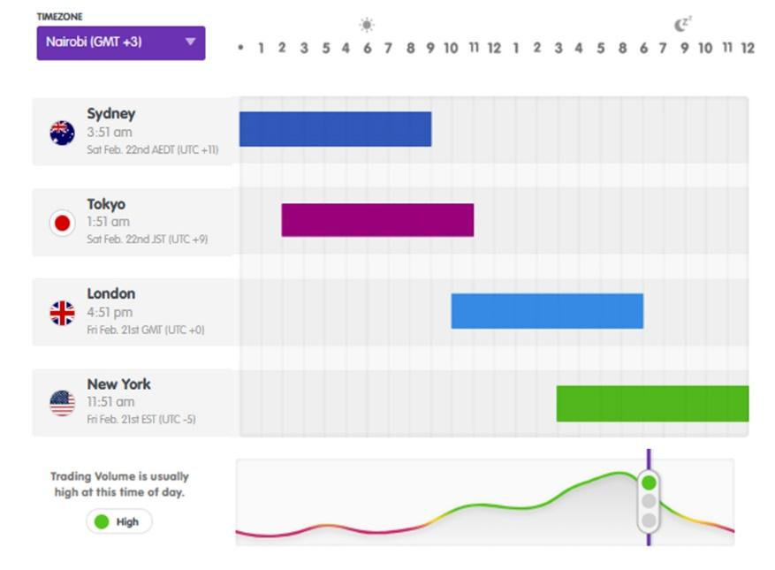

The forex market can be broken up into **four major trading sessions**: the **Sydney session**, the **Tokyo session**, the **London session**, and the **New York session**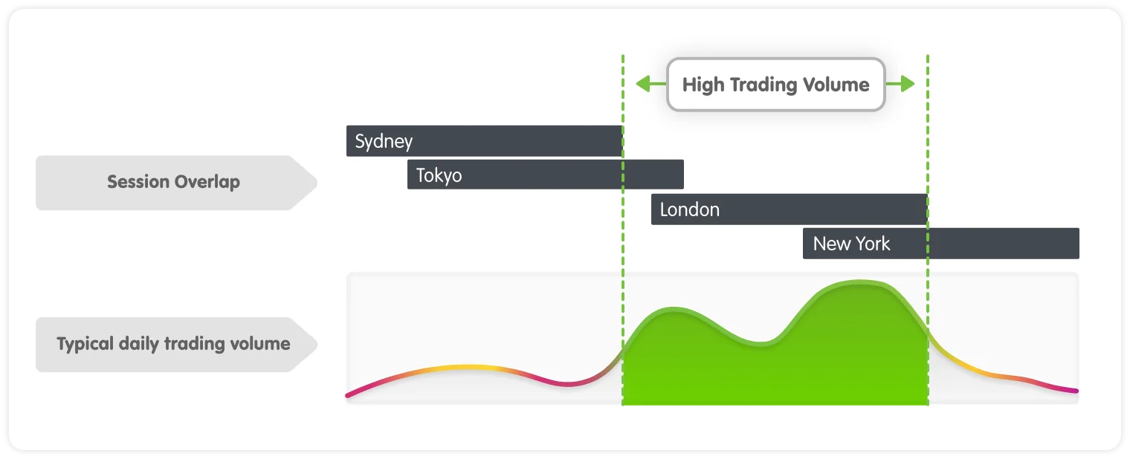.

**Forex Participants or players**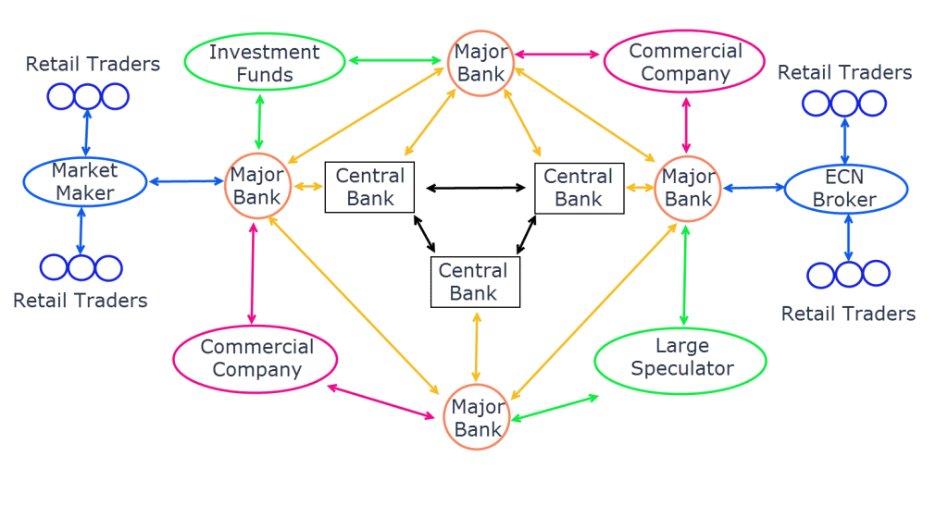

**Major Banks**: Provide **liquidity** and facilitating forex transactions. When you buy and sell you do this from the liquidity providers.

**Central Banks**: Regulate currency values through monetary policies, interest rates, and market interventions. {Regulates the value of a currency how high and low it can go}

**Commercial Companies**: Trade forex for international business transactions and **hedge** against currency risks.

**Investment Funds**: Engage in large-scale forex trading for profit and portfolio management.

**Large Speculators**: Trade high volumes in the forex market, primarily for speculation and profit.

**Market Makers**: Provide liquidity by setting bid and ask prices and facilitating transactions.

**ECN Brokers**: Connect retail traders to the forex market through electronic trading networks.

**Retail Traders**: Participate in forex trading on a smaller scale, speculating on currency movements using brokers or market makers.

***N/B***

***Liquidity****: How easy it is to buy or sell something without changing its price too much. In forex, high liquidity means you can trade currencies quickly without big price changes.*

***Hedge****: A way to protect yourself from losing money. In forex, people hedge by making trades that reduce the risk of currency price changes.*

***Brokers****: Companies that help people trade forex by providing a platform and connecting them to the market. They make money from small fees or price differences.*

***ECN Brokers****: Special brokers that connect traders directly to big banks and other traders, offering better prices and faster trades. They do not control prices but match buyers and sellers.*

**Currency**

* **Currency Pairs**: Currencies are traded in pairs 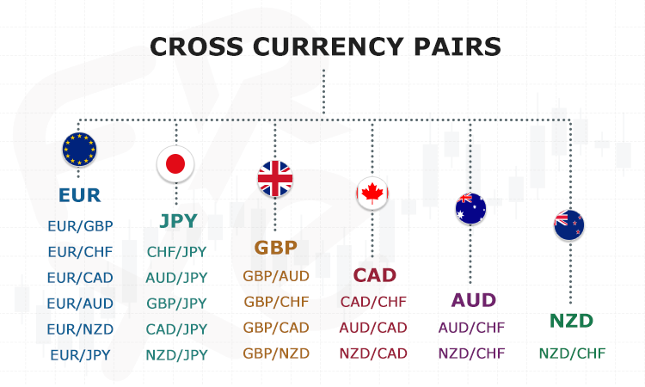(e.g., EUR/USD, GBP/JPY), meaning you buy one currency while selling another.
* Major - Minor/Cross - Exotic

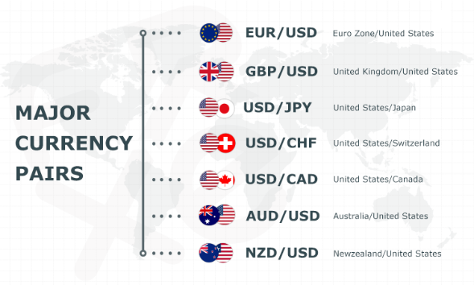

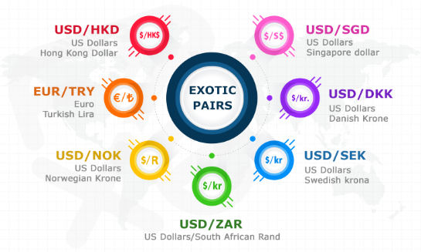

Indices-- S&P 500 - (US30) – NASDAQ 100 - FTSE 100 - DAX 40

Metals --- Gold (XAU/USD), Silver (XAG/USD), Platinum (XPT/USD), Palladium (XPD/USD), Copper (COPPER/USD)

Stock -- Apple Inc. (AAPL), Nvidia Corp. (NVDA), Tesla Inc. (TSLA)

Cryptocurrency – Bitcoin (BTC/USD), Ethereum (ETH/USD), Ripple (XRP/USD), Litecoin (LTC/USD), Solana (SOL/USD)

**Exchange Rate**

* **Exchange Rate**: The price of Base currency relative to Quote fluctuates based on **economic factors**, geopolitical events, and market demand.

• **Economic factors**: Things like inflation, interest rates, and employment that affect money and business.

• **Geopolitical events**: Things happening around the world, like elections or conflicts.

• **Market demand**: How much people want to buy things.

* usd/kes =130

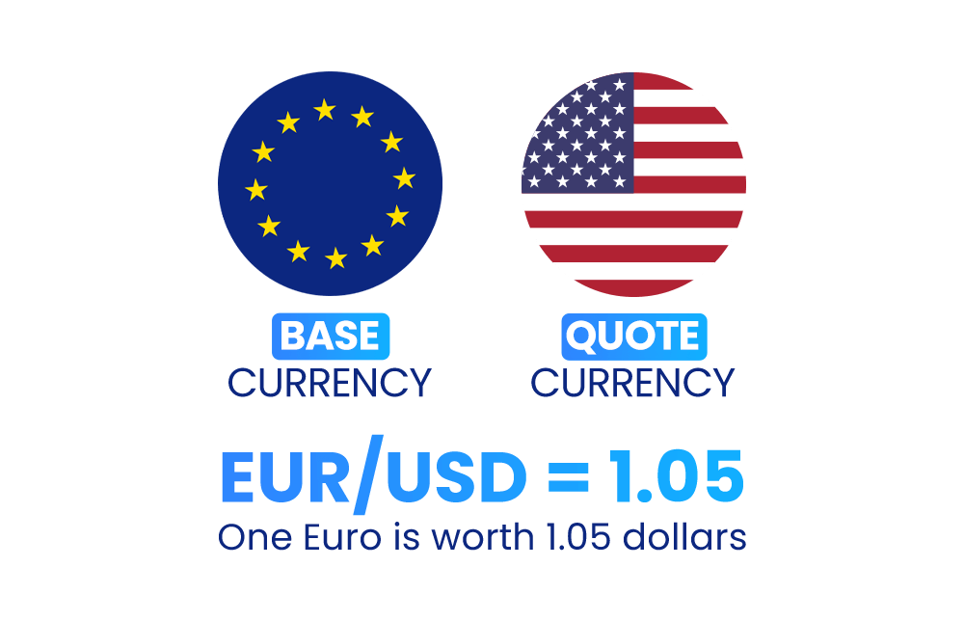

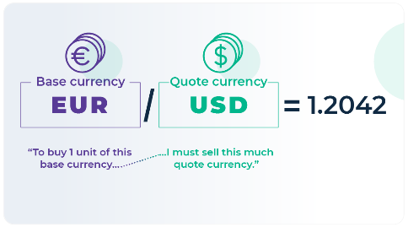

The exchange rate tells you how much of the **quote** currency **(USD)** you need to purchase one unit of the **base** currency (EUR). **1EUR = 1.05 USD**

**How We Make Money in forex**

We make profit in forex when the **exchange rate** **moves up or down**. This movement is measured in **pips.**

A **pip- percentage in points** is a change in the price of a currency. Traders use pips to measure profits and losses. For example, if the price of a currency goes from 1.2000 to 1.2005, it moved 5 pips.

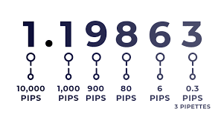

EUR/USD

1.12457

1.12467

}

+1 Pip

**Initial Conversion**: Convert 500 EUR to USD at an exchange rate of 1.12457.

1Eur = 1.12457Usd

= .29 USD

500Eur =?

* Result: 562.29 USD.

**10 days later no** **Spending**: Kept the 562.29 USD without using it.

**Return Conversion**: Convert 562.29USD back to EUR at an exchange rate of 1.12467.

*After 10 days, the exchange rate shifts to 1 EUR = 1.12467 USD*

1Eur = 1.12467 Usd

? = 562.85 Usd

Result: 500.05 EUR.

**Profit**: Small profit of 0.05 EUR due to the slight change of 1pip in exchange rates.

*N/b*

*If the exchange went down by 1 pip from 1.12457 to 1.12447, you would have a loss of - 0.04 EUR*

**How traders make money {Lot size}**

To actually make good money in forex like banks you have to have a good investment that's why brokers introduced lot sizes to help traders get more profits

When you place a trade, you have to trade **in little currency blocks or units**. These little blocks are called **Lots**".

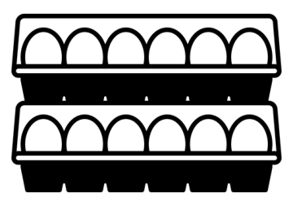**There are three basic Lot Sizes:**

When you place orders on your trading platform, orders are placed in sizes quoted in lots.

It’s like buying eggs in a whole seller. When you buy eggs from a whole seller, you usually **buy a carton**. **One carton includes 12 eggs**.

Micro Lot = $1,000 worth of currency ------ 0.01

Mini Lot = $10,000 worth of currency ------ 0.10

Standard Lot = $100,000 worth of currency ----- 1.00

The Lot size is how you will determine what each PIP you earn is worth.

**Margin & leverage Trading**

**Leverage**

Having the ability to control a large amount of money using very little of your own money and borrowing the rest.

For example, to control a $100,000 position, your broker will ask for a Down payment (margin) of $1,000 from your account. Your leverage, which is expressed in ratios, is now 100:1

100 x 1000 = 100,000

**Margin**

When trading forex, you are only required to put up a small amount of capital to open a large position. **[Down Payment]**

Imagine you want to buy a car that costs $20,000, but you don't have the full amount to pay upfront. Instead, you make a **down payment** of **$4,000** and borrow the remaining $16,000 from the bank as a car loan.

In this scenario, your down payment of $4,000 is like the "margin" in trading. It's the amount of money you put up front to secure the car (or in trading, to secure a position). The loan from the bank is similar to using leverage in trading, where you can control a larger amount of money than you initially invested.

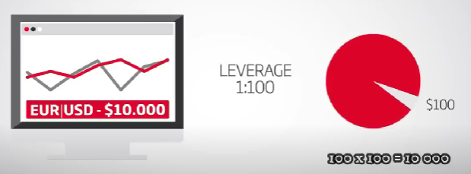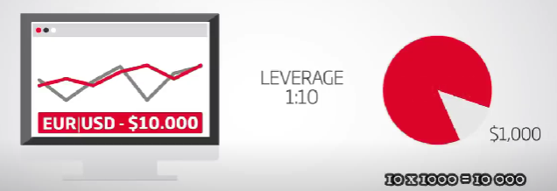

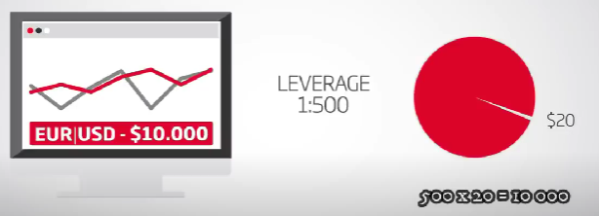

1pip = 0.01 micro

5pips =? ------ 0.50 Usd

1pip = 0.10 mini

5pips=? ------ 5 Usd

1pip = 1.00 standard

5pips =? ------ 50 Usd

*N/b*

*In case of losses this value will be paid with the margin.*

*Trading on big leverage can cause big loses use Risk management.*

**Brokers**

### ****What are forex brokers****

A **forex broker** is a company that **lets you buy and sell currencies** in the forex market. By helping you do this many brokers charge a fee **swap &**  spread which.

A **swap** in forex trading is the interest fee paid or earned for holding a position overnight.

A forex broker like a **shop** where you exchange money. Instead of going to a physical money exchange, you use an online platform to trade currencies.

**Example:**

* You want to trade **USD/KES** (US Dollars to Kenyan Shillings).
* The broker provides the price and allows you to **buy or sell**.
* If the price moves in your favor, you **make a profit**. If it moves against you, you **lose money**.

### ****What Does a Forex Broker Do?****

**Gives you access to the forex market** 🏦  
**Provides a platform like MetaTrader 4 (MT4) or MT5** 📈  
**Allows you to trade with leverage (borrowed money)** 💰  
**Charges spreads or commissions** as a fee 💵

**Spreads**

A **spread** is the **difference between the buying price (ASK) and the selling price (BID)** of a currency pair.

You go to a forex broker, and they show these prices for **EUR/USD**:

* **We buy 1 EUR at 1.0990 USD** (BID price).
* **We sell 1 EUR at 1.0992 USD** (ASK price).

The difference (**1.0992 - 1.0990 = 0.0002 or 2 pips**) is the **spread**.

### ****How Brokers Use Spreads:****

**Tight spread (small difference)** → **Cheaper to trade**  
**Wide spread (big difference)** → **More expensive to trade**

**Example in Forex:**

* **Bid Price (Sell EUR/USD)** = **1.0990**
* **Ask Price (Buy EUR/USD)** = **1.0992**
* **Spread = 0.0002 (or 2 pips)**

**When you open a trade, you start in a small loss because of the spread. To make a profit, the price must move beyond the spread!**

## ****Types of Forex Brokers****

Forex brokers operate using different models. The main types are:

### ****1. Market Makers (Dealing Desk - DD)****

* Brokers **create their own market** and take the opposite side of your trade.
* They **set the bid and ask prices**, meaning they can manipulate spreads.
* Often have **fixed spreads**.
* Best for **beginners** who want stable pricing.

**Example**: If you buy USD/KES, the broker may take the opposite position and fill your order internally rather than sending it to the real market.

### ****2. ECN Brokers (Electronic Communication Network - No Dealing Desk, NDD)****

* Directly connect traders to **liquidity providers** (banks, hedge funds, etc.).
* Offer **tight spreads** but charge a **commission per trade**.
* No price manipulation—real market prices.
* Best for **professional traders** who need fast execution.

**Example**: If you buy USD/KES, your order is matched with another trader or liquidity provider instead of the broker acting as a middleman.

### ****3. STP Brokers (Straight-Through Processing - No Dealing Desk, NDD)****

* Similar to ECN, but orders are **sent directly to liquidity providers** without an internal dealing desk.
* No commissions, but spreads are slightly marked up.
* Best for traders who want **fast execution** without commission fees.

**Example**: If you place a trade, the broker forwards it to a bank or financial institution to execute the order.

## ****Key Factors When Choosing a Forex Broker****

When selecting a broker, consider:

✅ **Regulation** – Ensure they are licensed by bodies like **CMA (Kenya)**, **FCA (UK)**, **CySEC (Europe)**, or **NFA (USA)**.  
✅ **Spreads & Fees** – Lower spreads and fair commissions mean lower costs.  
✅ **Leverage** – Some brokers offer leverage up to **1:500**, but use it cautiously.  
✅ **Deposit & Withdrawal Options** – Ensure they support **M-Pesa, bank transfers, PayPal, crypto, etc.**  
✅ **Trading Platform** – Popular ones include **MetaTrader 4 (MT4), MetaTrader 5 (MT5), cTrader, and TradingView**.  
✅ **Customer Support** – Should be available **24/7** with fast response times.

## ****Best Forex Brokers in Kenya**** 🇰🇪 1️⃣ **Exness** – Low spreads, high leverage, M-Pesa deposits. 2️⃣ **HotForex (HFM)** – Regulated, multiple account types. 3️⃣ **FXPesa** – CMA regulated, local deposits. 4️⃣ **Pepperstone** – ECN broker, fast execution. 5️⃣ **XM** – No deposit fees, high leverage.

**Broker Navigation**

### ****Navigating the Broker’s Trading Platform****

* Logging in and setting up an account
* Exploring the dashboard (balance, equity, margin, open trades)
* Using MetaTrader 4/5 (MT5) or cTrader
* 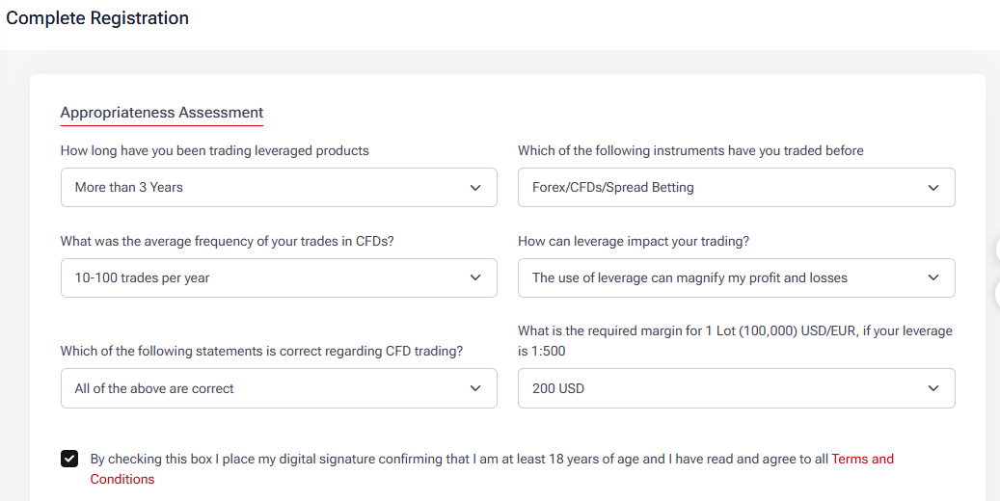Placing market and pending orders

## 

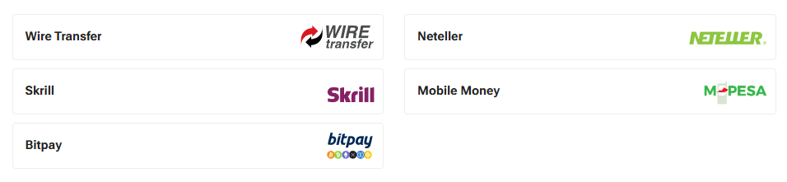

Video Url

**How to Create A TRADING ACCOUNT WITH HF MARKETS**—https://youtu.be/nDwUclXyGO4

**How To Connect HFM To Metatrader5 (Mt5)--** https://youtu.be/jqQEtjMKtXM

## Fundamental Analysis

## ****Key Factors in Fundamental Analysis****

### ****1. Economic Indicators****

These reports show a country’s economic health and affect its currency value.

* **Interest Rates** – Higher rates = stronger currency
* **Inflation (CPI, PPI)** – High inflation = weaker currency
* **Gross Domestic Product (GDP)** – Strong GDP = stronger currency
* **Employment Data (NFP, Unemployment Rate)** – More jobs = stronger currency

### ****2. Central Bank Policies****

* **Federal Reserve (USD), ECB (EUR), BOE (GBP), etc.** control interest rates and money supply.
* When a central bank **raises rates**, its currency **strengthens**.
* When it **lowers rates**, the currency **weakens**.

### ****3. Political & Global Events****

* **Elections, wars, and trade agreements** affect currency stability.

### ****4. News Releases & Market Sentiment****

* **High-impact news** (like the US **Non-Farm Payrolls (NFP)** or **FOMC meetings**) creates volatility.
* Traders watch the **Forex Factory calendar** for major events.

**Sentiment Analysis in Forex**

Sentiment Analysis (SA) is a trading method that looks at how traders and investors feel about the market. It helps determine whether most people are buying or selling a currency.

**Key Terms**

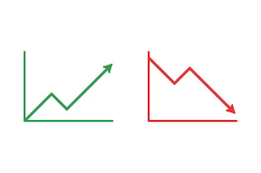🔵 **Bullish = Price Going Up**

* When traders say they are **bullish**, they believe the price will **increase**.
* Example: "I am bullish on EUR/USD" means they think the Euro will rise against the Dollar.

🔴 **Bearish = Price Going Down**

* When traders say they are **bearish**, they believe the price will **decrease**.
* Example: "I am bearish on USD/JPY" means they expect the US Dollar to fall against the Japanese Yen.

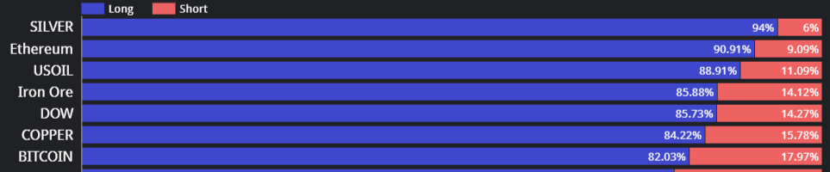

[***https://www.a1trading.com/retail-sentiment/***](https://www.a1trading.com/retail-sentiment/)

[***https://www.oanda.com/bvi-en/lab-education/tools/sentiment/***](https://www.oanda.com/bvi-en/lab-education/tools/sentiment/)

***https://www.myfxbook.com/community/outlook***

***4hrs***

**How Sentiment Analysis Works**

Bullish Sentiment – Traders believe the price will go up 📈 → More buyers.

Bearish Sentiment – Traders believe the price will go down 📉 → More sellers.

Neutral Sentiment – Traders are undecided, and the price moves sideways.

**Forex Sentiment Indicators**

Retail Trader Sentiment (RTS) – Found on brokers like OANDA, a1trading, Myfxbook.

Example: If 80% of traders are buying EUR/USD, it may indicate a sell opportunity (contrarian view).

**Example: Sentiment Analysis on EUR/USD**

COT Report shows **big investors** are **buying** EUR/USD.

**Oanda.com** Sentiment shows **80% of retail traders are selling** EUR/USD.

Contrarian traders might **buy** EUR/USD because retail traders are usually wrong.

**Technical Analysis: - Candle stick Patterns**

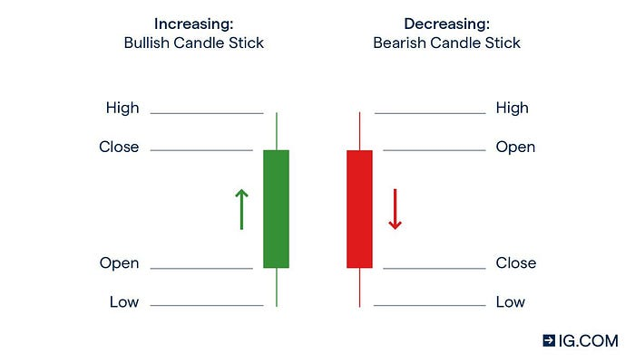A **candlestick** is a representation of price movement within a period of time. (e.g., 1 minute, 1 hour, and 1 day).

**Bullish Candle (Price Goes Up 📈)**

* Open price (**bottom** of the body)
* Close price (**top** of the body)
* Wicks (thin lines) show the **highest** and **lowest** prices

**Bearish Candle (Price Goes Down 📉)**

* Open price (**top** of the body)
* Close price (**bottom** of the body)
* 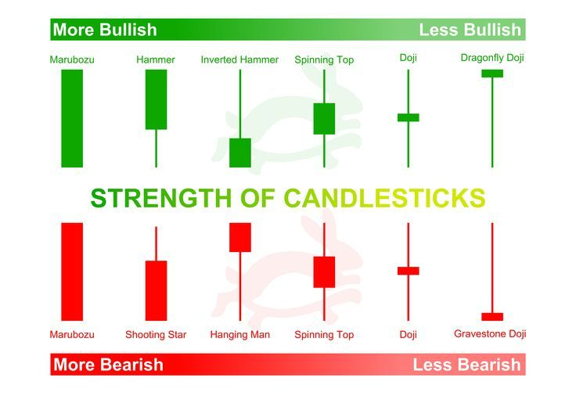Wicks (**thin lines**) show the **highest** and **lowest** prices

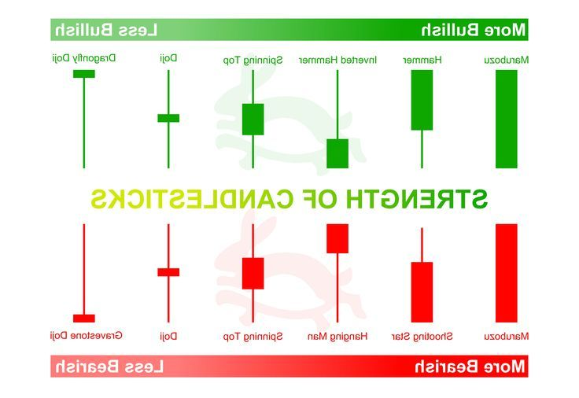

}

Price went up and got pushed down by sellers hence (selling pressure)



**Buying and selling pressure**



Price went down and got pushed up by buyers (buying Pressure)

}



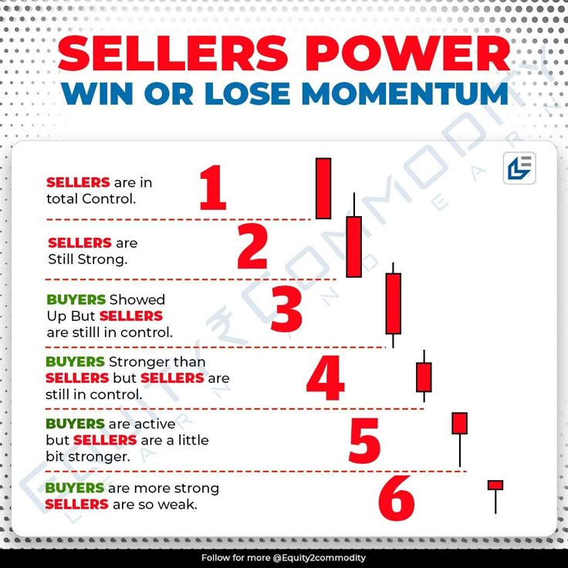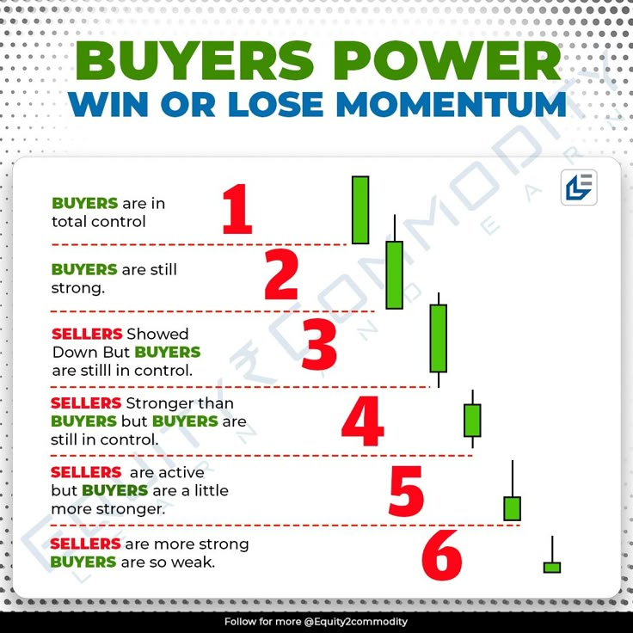

**Why Candlesticks Matter?**

They help traders see market trends quickly.

They show who is in control (buyers or sellers).

They form patterns that traders use to predict the next move.

**Where to use candle sick patterns**

Support and Resistance

Retest at valid trend line

Retest at Fair Value Gap (FVG)

Uptrend HH, HL, LL, LH

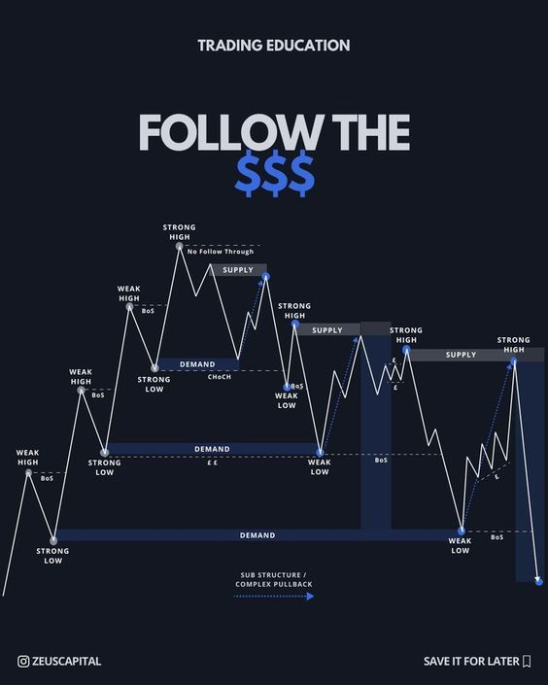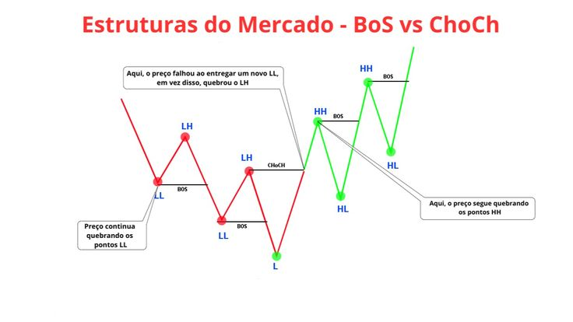**Technical Analysis: - Market structure**

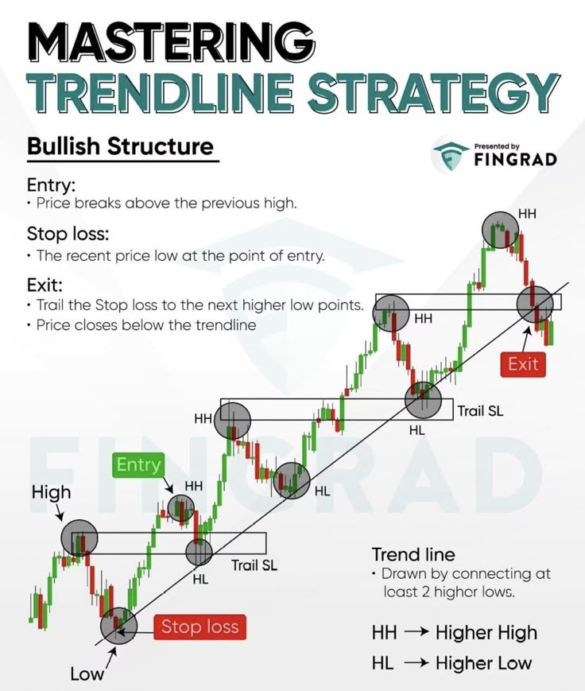

• **CHOCH** – **Change of Character** (A shift in market structure, signaling a potential trend reversal.)

• **BOS** – **Break of Structure** (A confirmation that the trend is continuing in the same direction.)

• **HH** – **Higher High** (A new high that is higher than the previous high, indicating an uptrend.)

• **HL** – **Higher Low** (A new low that is higher than the previous low, confirming an uptrend.)

• **LL** – **Lower Low** (A new low that is lower than the previous low, showing a downtrend.)

• **LH** – **Lower High** (A new high that is lower than the previous high, confirming a downtrend.)

• **Supply** – **A price level where selling pressure is high, causing price to drop.**

• **Demand** – **A price level where buying pressure is strong, causing price to rise.**

**Technical Analysis: - Supply and Demand**

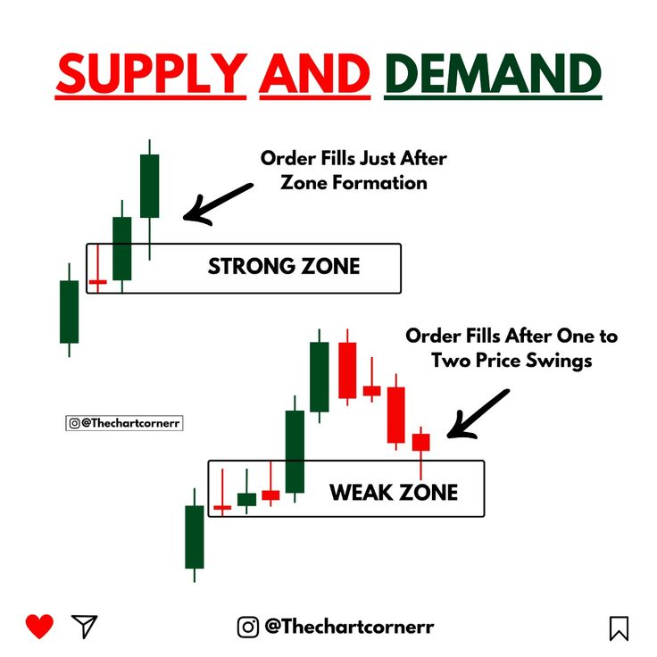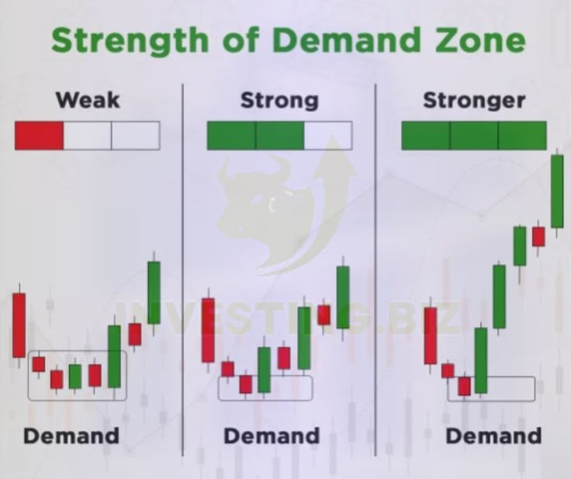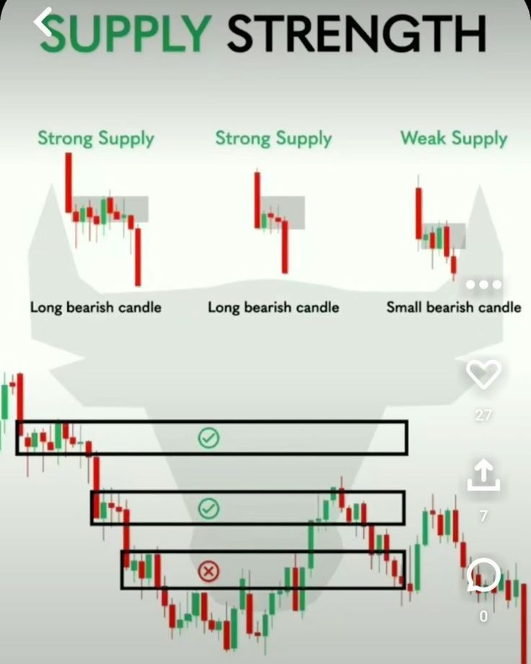

**Technical Analysis: - Chart Pattens**

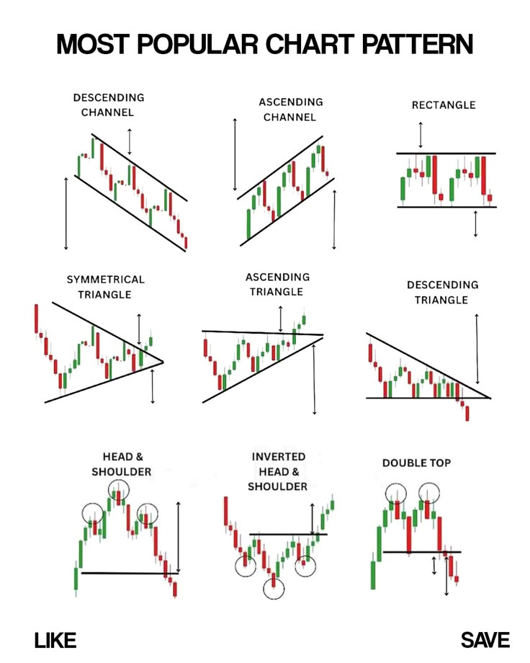





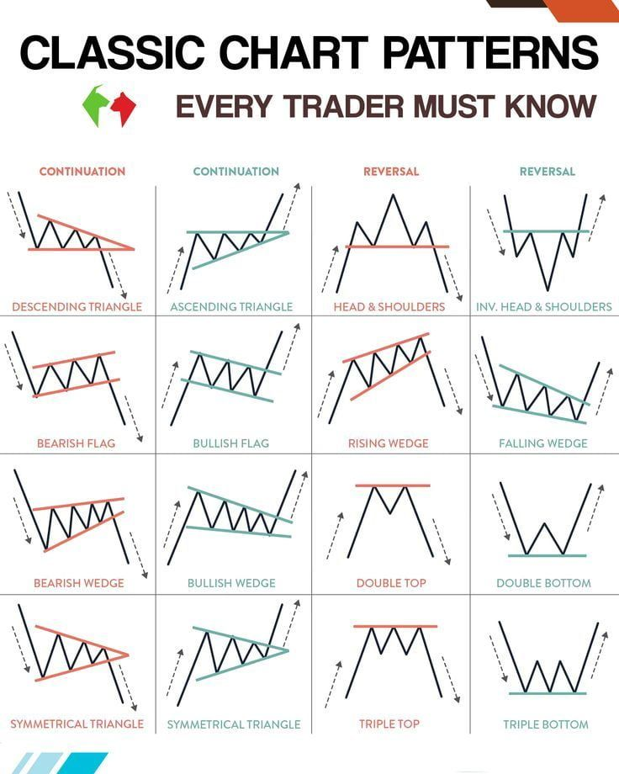

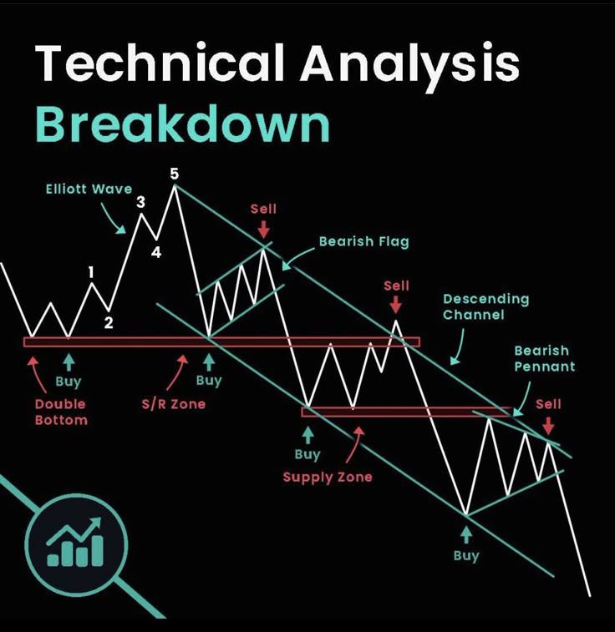



**Introduction to Trading Platforms (MT5)**

**MetaTrader 5 – Order Types**

Order types:

**Buy Stop**

You set a price higher than the current price, and if the price reaches it, you buy because you think it will keep going up.

**Sell Stop**

You set a price lower than the current price, and if the price reaches it, you sell because you think it will keep going down.

**Buy Limit**

You set a lower price than the current price, and if the price drops to it, you buy because you think it will go up later.

**Sell Limit**

You set a higher price than the current price, and if the price rises to it, you sell because you think it will go down later.

**Buy Stop Limit**

First, you set a price above the current price. If it reaches that price, a new buy order is placed, but only if the price stays within a certain range.

**Sell Stop Limit**

First, you set a price below the current price. If it reaches that price, a new sell order is placed, but only if the price stays within a certain range.

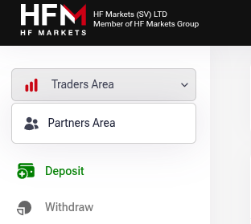

**HFM To MT5**

Change Area – to Traders Area

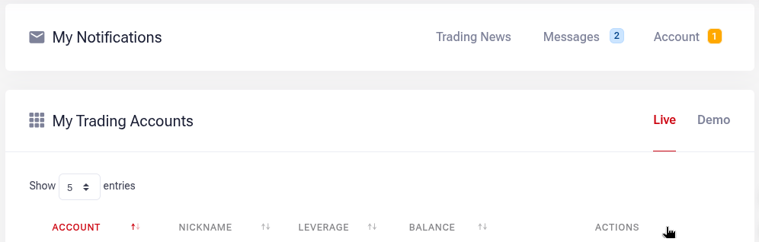

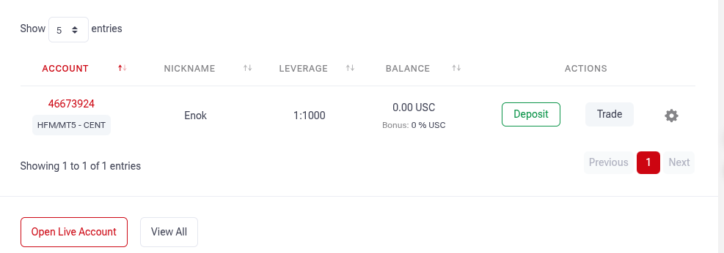

### ****MetaTrader 5 (MT5)****

### ****Placing Trades on MT5****

* Click **New Order** or press **F9** to open the order window.
* Choose the asset (EUR/USD, Gold, etc.).
* Select **Order Type** (Market Execution or Pending Order).
* Set **Lot Size**, **Stop Loss**, and **Take Profit** levels.
* Click **Buy** or **Sell** to execute the trade.

### ****Managing Open Trades****

* Check trades in **Toolbox > Trade tab**.
* Modify Stop Loss & Take Profit by dragging lines on the chart.
* Close trades manually when needed.

**Risk Management**

**Importance of Risk Management**

**Risk management helps prevent large losses and protects trading capital.**

Key principles:

* Never risk more than **0.5 - 2%** of your account per trade.
* Great RR --- 1:2 -- 1:5
* Use **Stop Loss (SL)** to limit losses.
* Avoid **over-leveraging**, as it increases risk.
* 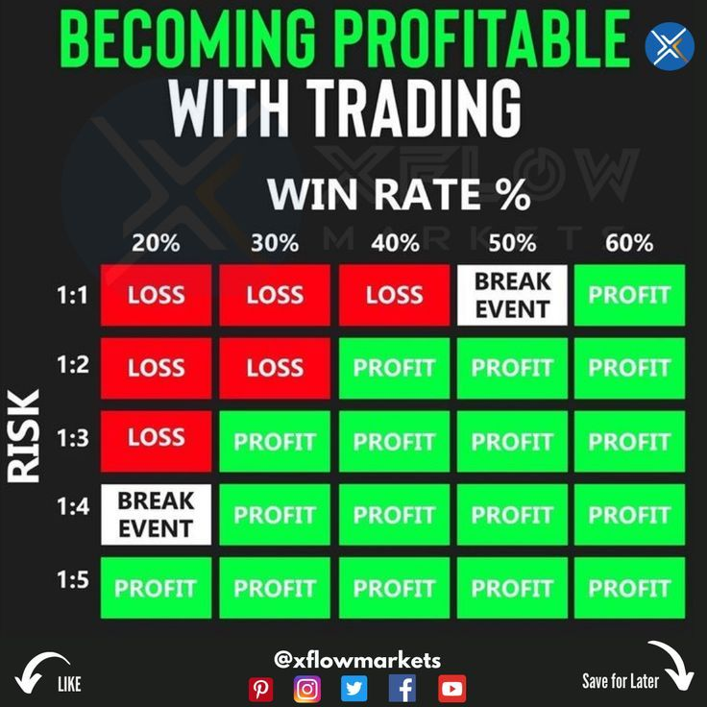Poor risk management can lead to account blowouts.

### *****MT5 Practical Session*****

Open a demo trade without a stop loss to see potential risks.  
Check margin, balance, and free margin in the **Terminal Window**.

**Calculating Risk/Reward Ratio (RRR)**

Formula:

Potential Profit

RRR =

Potential Loss

Example: If SL = 30 pips and TP = 60 pips, the RRR = 1:2.

A higher RRR (e.g., 1:2 or 1:3) increases long-term profitability.

**Setting Stop Loss (SL) and Take Profit (TP)**

Stop Loss (SL): Limits losses when the trade goes against you.

Take Profit (TP): Locks in profits automatically.

Methods to determine SL and TP:

ATR (Average True Range) method – use the ATR indicator.

Support and Resistance Levels – place SL below support or above resistance.

Fixed Pip-Based SL – e.g., 30 pips SL, 60 pips TP (RRR 1:2).

**Calculating Position Size**

Account Balance = $1,000

Risk Per Trade = 2% of balance = $20

Stop Loss = 30 pips

Currency Pair = EUR/USD (pip value for 1 lot = $10)

Risk Per Trade

Stop Loss (pips) × Pip Value

Lot Size

20

20

30 × 1

Lot Size

30

0.67 mini lot

=

=

## ****Introduction to Trading Strategies****

### ****Types of Trading Strategies****

1. **Scalping**
   * **Timeframe:** 1-minute to 5-minute charts.
   * **Trade Duration:** Seconds to minutes.
   * **Goal:** Small, quick profits from short price movements.
   * **Tools Used:** Moving Averages, RSI, Bollinger Bands.
2. **Day Trading**
   * **Timeframe:** 5-minute to 15-minute charts.
   * **Trade Duration:** A few hours (all trades closed by end of the day).
   * **Goal:** Capture intraday price movements.
   * **Tools Used:** Support & Resistance, Moving Averages, MACD.
3. **Swing Trading**
   * **Timeframe:** 4-hour to daily charts.
   * **Trade Duration:** Days to weeks.
   * **Goal:** Capture larger price swings.
   * **Tools Used:** Trendlines, Fibonacci, RSI.

**Price Action Trading Basics**

1. **Support & Resistance**
   * **Support:** A price level where buyers step in, preventing further decline.
   * **Resistance:** A price level where sellers step in, preventing further rise.
   * **Tip:** Look for areas where price has reversed multiple times.

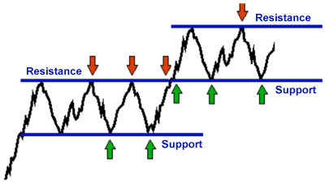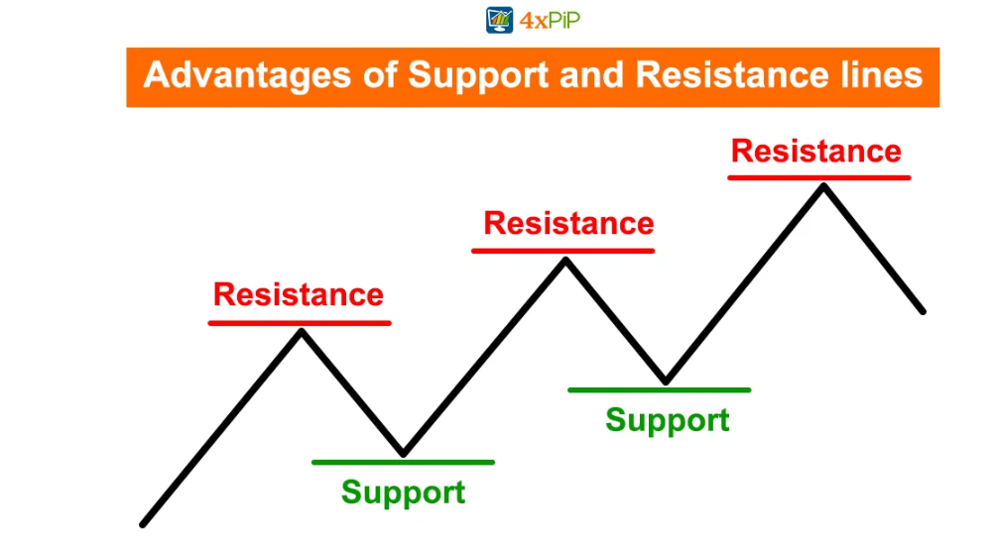

1. **Trendlines**
   * **Uptrend:** Higher highs and higher lows.
   * **Downtrend:** Lower highs and lower lows.
   * 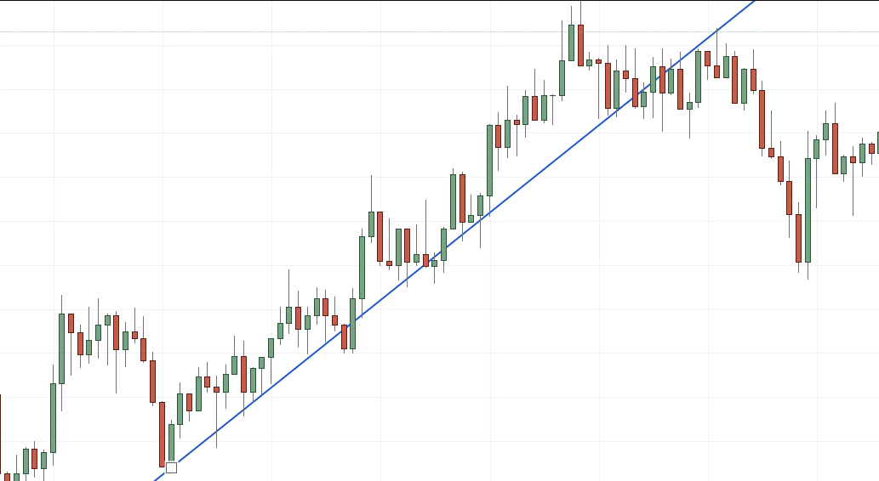**How to draw:** Connect at least two swing lows (for an uptrend) or two swing highs (for a downtrend).
2. **Candlestick Patterns**
   * **Reversal Patterns:**
     + Pin Bar (Strong rejection of price).
     + Engulfing (Big candle covers previous candle).
   * **Continuation Patterns:**
     + Inside Bar (Indicates a breakout is coming).
     + Trendline Bounce (Price respects a drawn trendline).

### ****Back testing Price Action Strategies****

### ****Why Backtesting is Important?****

* Tests how well your strategy performs over past data.
* Identifies weaknesses before live trading.

### ****MT5 Backtesting Guide****

1. Open a historical chart and **scroll back in time**.
2. Identify key **support & resistance, trendlines, and patterns**.
3. Track **price reaction** at those levels.
4. Note down **win/loss rate** and refine entry points.

**Smart Money Concept (SMC) Trading Guide**

Smart Money Concept (SMC) is a trading strategy based on **institutional order flow**, focusing on how big banks and financial institutions trade. It helps traders identify **high-probability trade setups** using **liquidity, market structure, and order blocks** instead of traditional indicators.

**Market Structure & Liquidity**

### ****1. Understanding Market Structure****

* **Break of Structure (BOS)** → when price breaks a key swing high/low, indicating trend continuation.
* **Change of Character (CHOCH)** → a shift in market structure signaling a possible reversal.

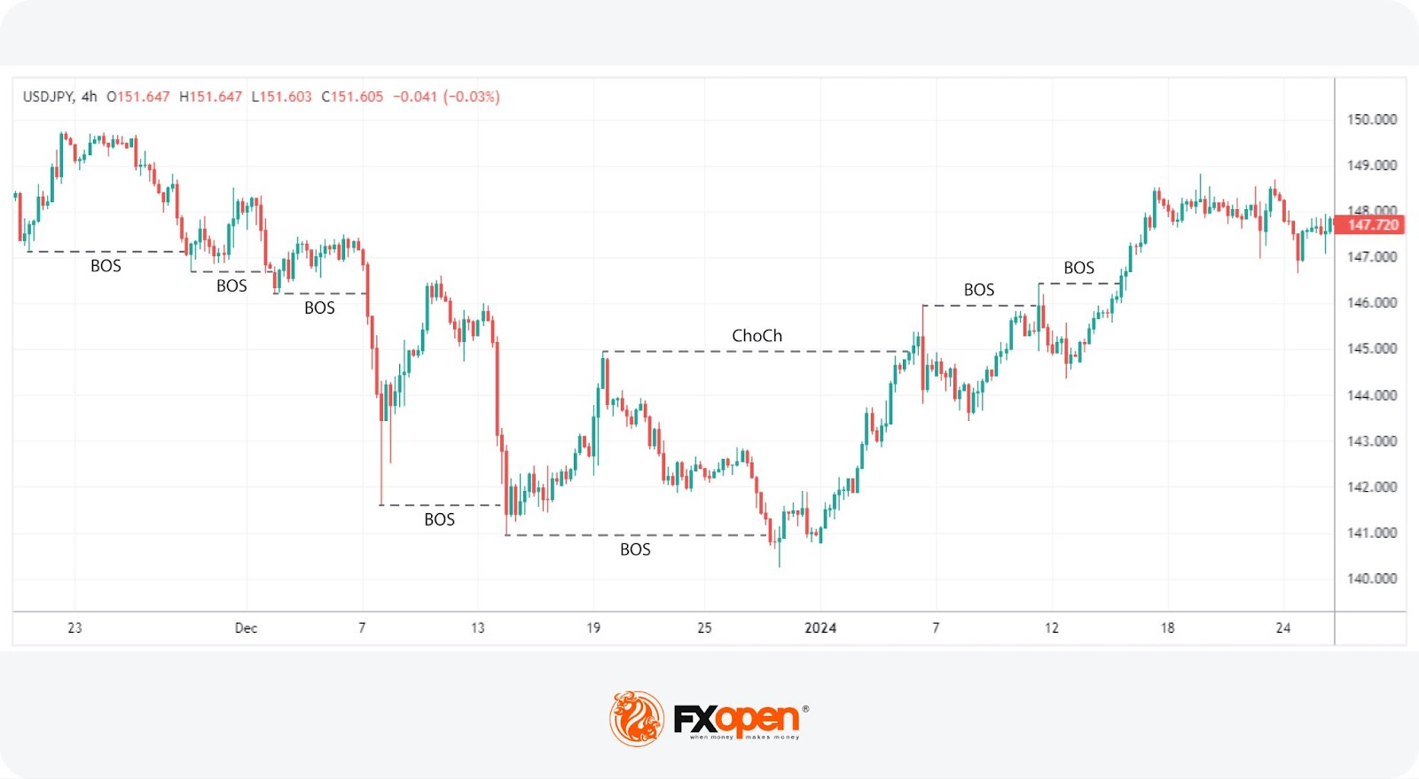

#### ****Market Structure Example****

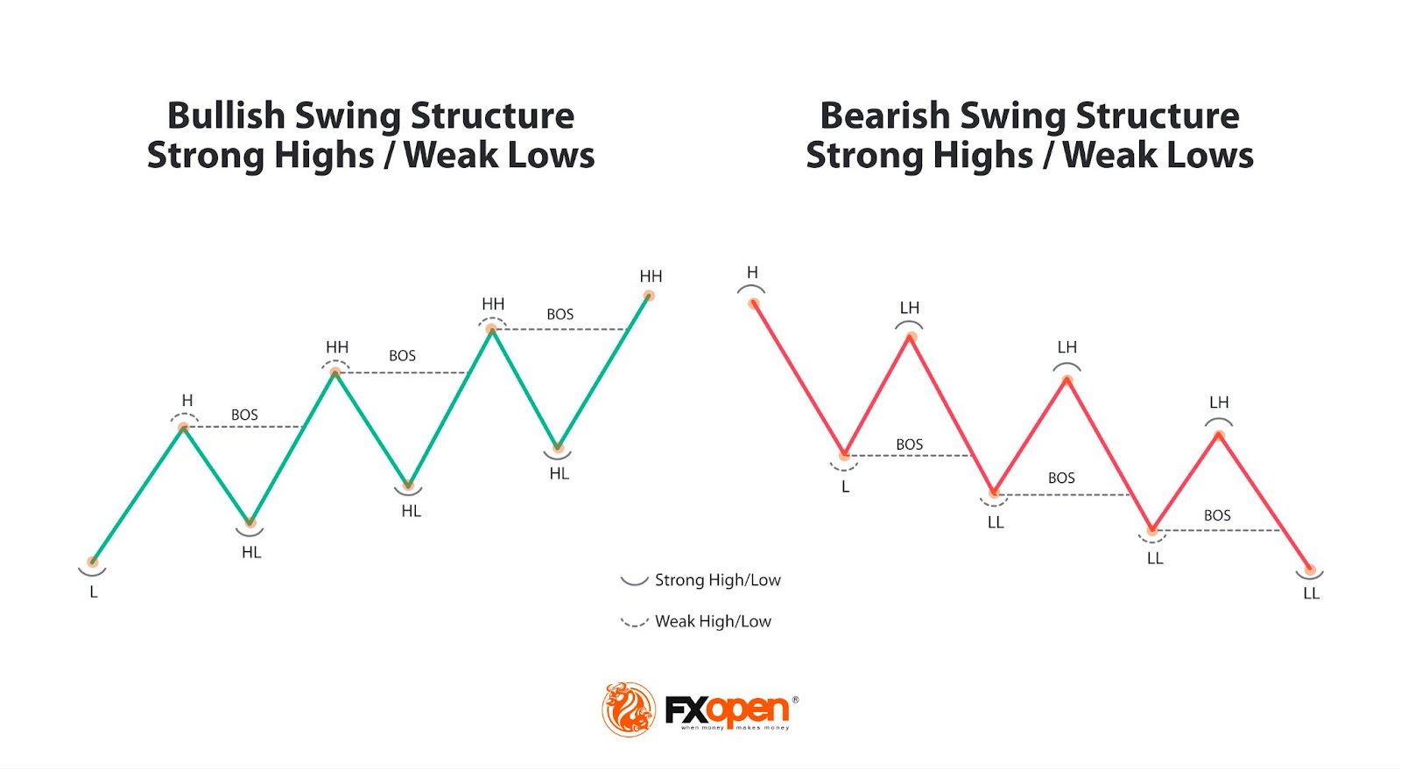🔹 **Uptrend:** Higher highs (HH) and higher lows (HL).  
🔹 **Downtrend:** Lower highs (LH) and lower lows (LL).

### ****Liquidity: Where Smart Money Traps Retail Traders****

* **Retail traders place stop-loss orders at obvious levels (above resistance, below support).**
* **Banks hunt this liquidity before reversing the market.**

#### ****Types of Liquidity Traps****

* **Buy-Side Liquidity (BSL):** Above resistance (stop-losses of sellers).
* **Sell-Side Liquidity (SSL):** Below support (stop-losses of buyers).
* 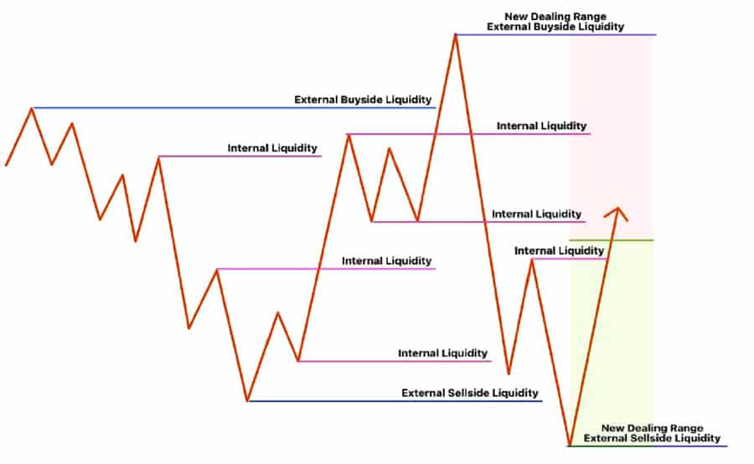**Liquidity Grab (Stop Hunt):** Sudden spike in price to trigger stop-losses before reversing.

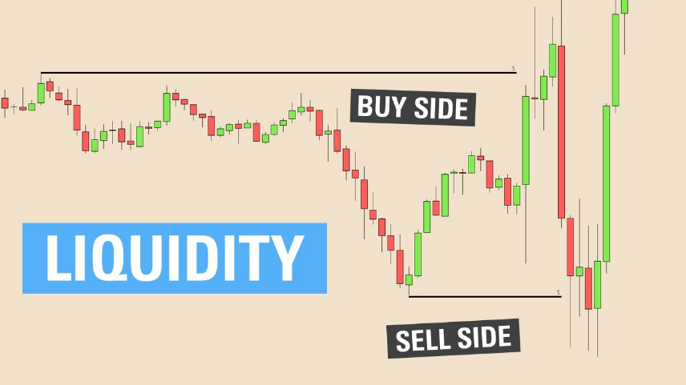

## ****Order Blocks & Institutional Trading****

### ****1. What Are Order Blocks?****

Order Blocks (OBs) are **zones where institutions placed large buy or sell orders** before a significant move. They act as **strong support/resistance zones**.

#### ****Types of Order Blocks****

* **Bullish Order Block:** A **bearish candle before a strong up move**.
* **Bearish Order Block:** A **bullish candle before a strong down move**.

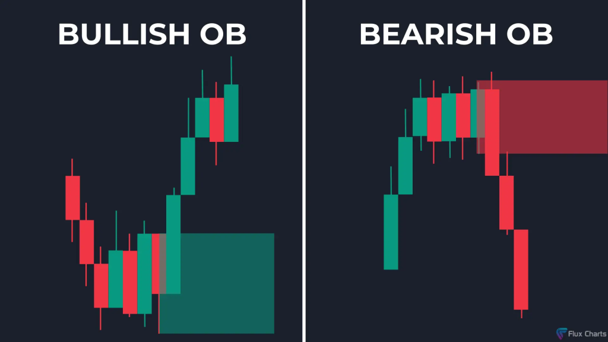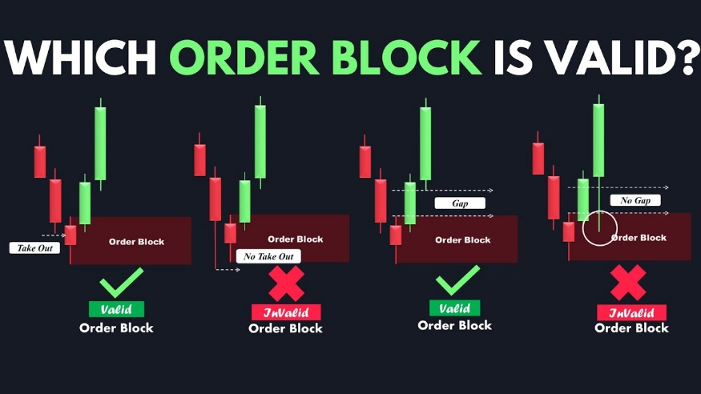

**How to Trade Order Blocks:**  
 Wait for price to **retest the OB** after a breakout.  
 Confirm with **market structure shift (CHOCH) at lower timeframes**.  
 Enter with a **tight stop-loss below the OB**.

## ****Fair Value Gaps & Mitigation Blocks****

### ****1. Fair Value Gaps (FVGs) – Market Imbalances****

* **FVGs occur when price moves too fast, leaving a gap in liquidity.**
* **Price often returns to fill the gap before continuing.**

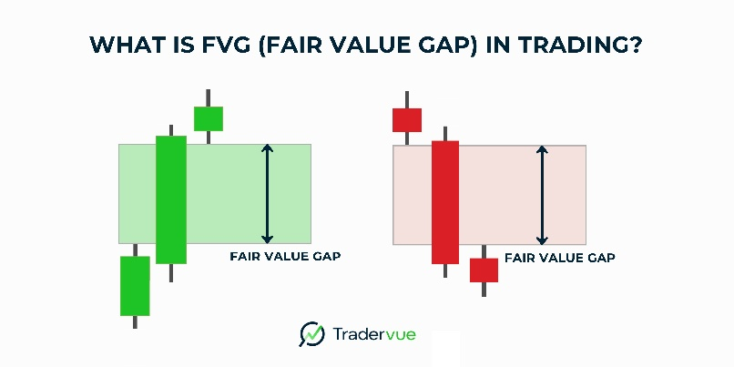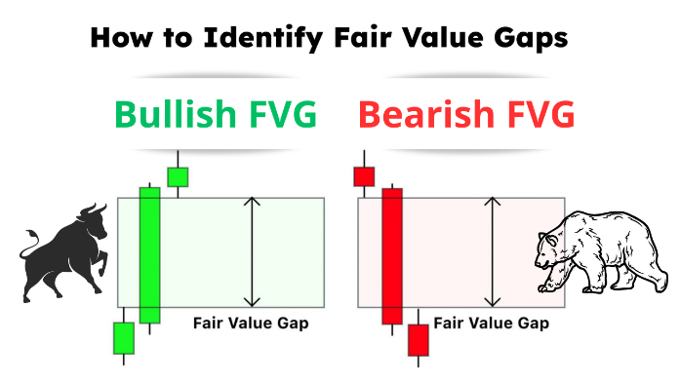

🔹 **How to trade FVGs:** Look for retracements into the gap for entries.

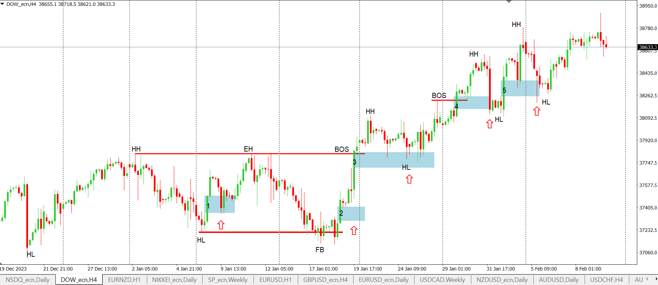

### ****2. Mitigation Blocks – Where Institutions Re-enter Trades****

* **Banks often revisit previous order blocks to execute more trades.**
* **Look for price retesting a previous supply/demand zone before continuing the move.**

## ****Applying Smart Money Concept in Live Trading****

### ****Trading Plan for SMC Entries****

1. Identify the **trend** using **market structure (BOS/CHOCH)**.
2. Look for **liquidity grabs** before the real move.
3. Find **order blocks** that align with the market trend.
4. Wait for **price retest + confirmation** before entering.
5. 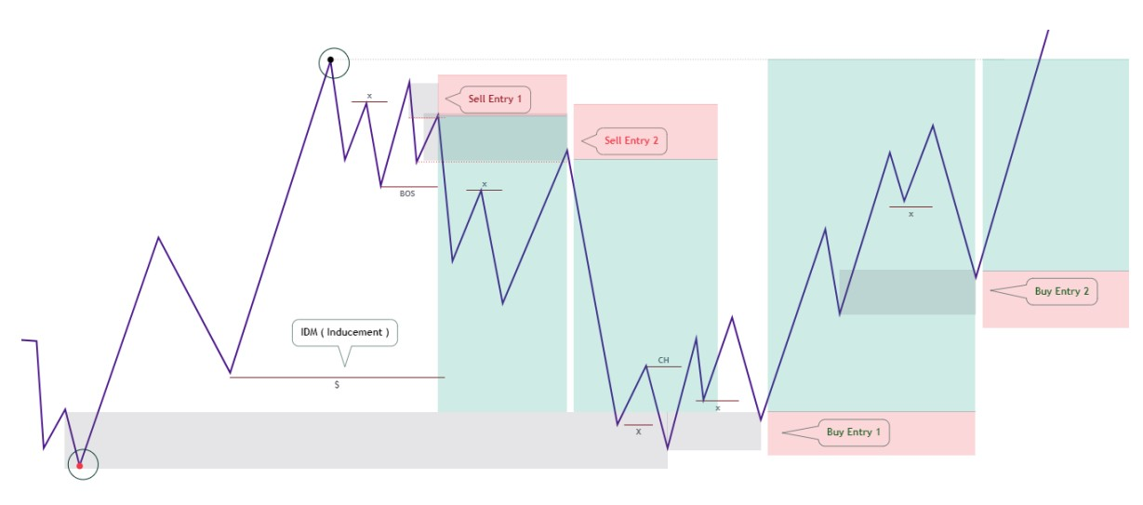Set **stop-loss** below the OB and **take profit** at the next liquidity zone.

### ****Trading Psychology****

#### ****Understanding Trading Psychology****

* Trading psychology refers to the mental and emotional aspects that influence trading decisions.
* Two dominant emotions in trading are **fear** and **greed**:
  + **Fear** can prevent taking valid trades or cause premature exits.
  + **Greed** can lead to over-trading or ignoring risk management rules.
* Common psychological traps:
  + **Overconfidence** after a series of wins.
  + **Revenge trading** after losses.
  + **Paralysis by analysis**—failure to act due to overthinking.
* Successful traders maintain objectivity and follow systems, not feelings.

#### ****Dealing with Losses****

* Losses are unavoidable; the goal is to manage them, not eliminate them.
* Emotionally detaching from outcomes helps maintain consistency.
* Never try to "win back" losses by increasing risk or deviating from your strategy.
* Evaluate losses logically: Was it a mistake or just a normal trade that didn’t work?

#### ****Managing Emotions****

* Emotions are triggered by uncertainty and financial stakes.
* Key to managing emotions is preparation: back-testing, planning, and strict rules.
* Techniques:
  + Use checklists before entering trades.
  + Take breaks after emotional trades.
  + Avoid trading when emotionally compromised (tired, stressed, angry).
* Consistent routines help reduce emotional instability.

#### ****Maintaining Discipline****

* Discipline means sticking to your plan—regardless of emotions or market noise.
* Trading without discipline = gambling.
* Ways to build discipline:
  + Trade only during set hours.
  + Limit the number of trades per day.
  + Follow written rules for entry, exit, and position sizing.
* Journalism helps track and enforce discipline.

### ****Building a Trading Plan****

#### ****Setting Trading Goals****

* Goals should be specific and measurable (e.g., 1%-2%-3% monthly return).
* Types of goals:
  + **Process goals**: Focus on following rules (e.g., no impulsive trades).
  + **Performance goals**: Focus on outcomes (e.g., profitable weeks).
* Avoid unrealistic goals—they lead to overtrading and stress.

#### ****Developing a Trading Plan****

* A trading plan is a written document that outlines:
  + Market(s) to trade.
  + Entry/exit strategies.
  + Indicators used (if any).
  + Position sizing rules.
  + Risk management guidelines.
* Your plan should reflect your personality, schedule, and risk tolerance.
* A clear plan removes guesswork and emotional decision-making.

#### ****Backtesting and Refining the Plan****

* Backtesting = testing your strategy on historical data to see how it performs.
* Essential for proving that your strategy works before risking real money.
* Track:
  + Win/loss ratio
  + Average profit/loss per trade
  + Drawdown periods
* Refine based on results: adjust stop losses, entries, or filters—but avoid curve fitting.

#### ****Risk Management within Your Plan****

* Never risk more than 1–2% of your total capital on a single trade.
* Use stop-loss orders to cap your losses.
* Calculate **Risk-to-Reward Ratio (RRR)**—aim for at least 1:2 or 1:3
* Proper risk management ensures you stay in the game even with a losing streak.

### ****Live Trading and Analysis****

#### ****Transitioning from Demo to Live Trading****

* Begin live trading with small capital to adjust to real emotional pressure.
* Expect a different feel—even if the strategy is the same.
* Focus is on **execution**, not profits.
* Build confidence gradually without increasing size too fast.

#### ****Analyzing Live Trades****

* Every trade should be logged: **setup**, **entry**, **exit**, and **the reason behind each action.**
* Analyze trades to:
  + Identify patterns in **wins/losses**.
  + Understand which setups are **most profitable.**
  + Detect recurring mistakes (late exits, **missed entries**).
* Use data, not **memory**, for **improvement**.

#### ****Journaling and Reviewing Trades****

* A trading journal should include:
  + Chart screenshots
  + Trade rationale
  + Emotional state during the trade
  + Outcome (P/L)
* Weekly reviews help:
  + Spot behavioral tendencies
  + Reinforce discipline
  + Modify **strategies when needed**
* **Journaling** turns experience into **structured learning.**

#### ****Adapting to Market Changes****

* Markets are dynamic: what worked last month may not work this month.
* Learn to identify different market conditions:
  + Trending
  + Ranging
  + Volatile
  + Low volume
* Adjust strategies based on volatility, news, and economic events.
* Stay flexible, but never abandon core principles of your strategy.